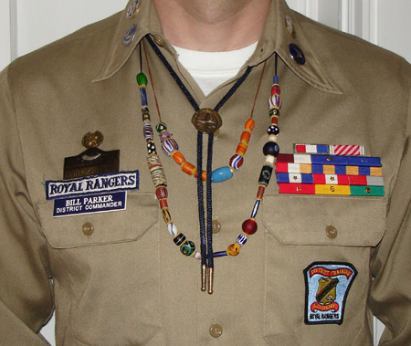
Did you know you could wear your FCF beads with your Royal Rangers khaki uniforms and with any class C uniform? All you need to do, is follow the 10 basic rules when you wear your beads, and you will be OK.
HERE ARE THE 10 RULES:
When/where to wear the beads:
1) FCF beads can be worn by FCF members with any uniform for which wearing a patch vest is acceptable, including all class B and class C uniforms.
2) Beads can be worn with the Royal Ranger uniform at all NC District, Divisional, Sectional, or Outpost events, but not at Regional or National Events.
How to wear beads:
3) Event beads are to be worn in a single strand or multiple strands, strung on brown or black thread, on a necklace to be worn under the collar (like a bolo tie). (The Chapter bead guy has some thread that we can use, so that we all look alike. It's pretty cool thread that won't break real easy, so your beads will be safe on your neck.)
4) To space the beads, small brown or black, leather or wood spacers can be placed between the event beads to protect the event beads from wear, if desired. (You can put them on the strand against each other, but some of them are glass and will chip or break, so a spacer is a really good idea.) The spacer should not stick out farther than the width of the largest bead it's next to, nor should it be thicker than the beads. (It should not become a "bead" in itself.)
5) The event beads should be ordered from the wearer's right to left, starting with the first bead obtained on the right, and ending with the latest bead on the left. (See below on which beads to wear.) In the future, there will be enough event beads for everyone to purchase a second bead for the purpose of wearing them on this strand. Some duplicates from recent events are available.
6) If worn, ties should hang over the beads. (i.e. the beads should hang underneath any tie or bolo that is worn.)
7) The string should be long enough so that beads are below the first button of the shirt (i.e. the button that the bolo covers), but not longer than the ends on the bolo tie.
8) If the FCF member has more beads than can be worn without the strand hanging below the second button, or with beads hidden under the collar, then an additional strand or strands of beads should be worn.
Which beads to wear:
9) FCF members should only wear a bead if they attended the event represented by that bead as an FCF member. The beads obtained as a greenhorn may be included on the strand, if desired. Beads obtained while visiting FCF events as a guest (non-member) may not be worn on Royal Ranger uniforms.
10) FCF members should wear only one bead for each event attended with the exception that if a set of beads represents a single event, that set should be worn. (Note: If the Ranger attended two of the same type of event in a single year [for example, two frontier adventures in one year], then the Ranger may wear one bead for each event attended, even if the beads are the same.)

